Template for Evidence(s)
UI GreenMetric Questionnaire

University : ...
Country : ...
Web Address : …

[2] Energy and Climate Change (EC)
SAMPLE
[2.8] ratio of renewable energy production divided by total energy usage per year (EC.5)

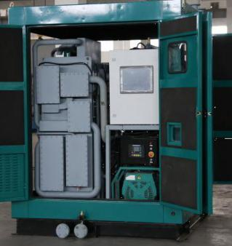 | 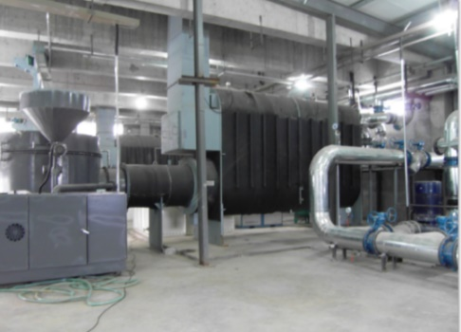
Example of Biodiesel Combined Cooling Heating and Power Integration Unit (Shandong Normal University - Lishan College, China) | Example of Biomass Pellet Vacuum Boilers Provide Heating for the Building in winter  (Shandong Normal University - Lishan College, China)
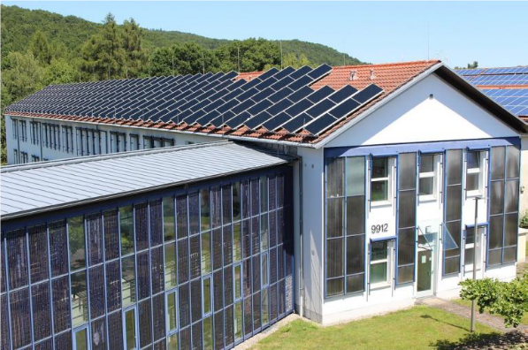 | 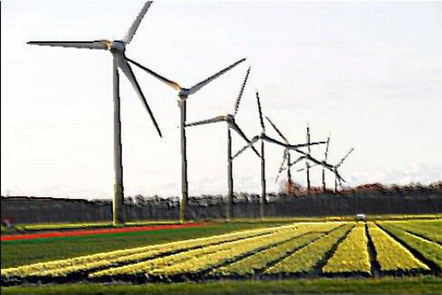
Example of Roof and Façade Mounted Solar Panels (Umwelt-Campus Birkenfeld, Germany) | Example of Windmill Parks (Wageningen University & Research, Netherlands)

Description:
(Please describe the renewable energy sources on your campus. The following is an example of the description. You can describe more related items if needed.)
No | Renewable Energy | Production (in kWh)
1 | Biodiesel | 5.000
2 | Biomass | 3.000
3 | Solar panel | 15.000
4 | Windmill | 3.500
 | Total | 26.500

26.500 / 100.000 (Electricity usage) = 26.5 %

Additional evidence link (i.e., for videos, more images, or other files that are not included in this file):

